*Heterogeneous flows foster heterogeneous assemblages: relationships between functional diversity and hydrological heterogeneity in riparian plant communities.*

James R. Lawson*1, Kirstie A. Fryirs2, Tanja Lenz1, Michelle R. Leishman1

1. Department of Biological Sciences, Macquarie University, North Ryde, NSW 2109, Australia
2. Department of Environmental Sciences, Macquarie University, North Ryde, NSW 2109, Australia

* [james.lawson@mq.edu.au](mailto:james.lawson@mq.edu.au), fax: +61 2 9850 8245, phone: +61 2 9850 8160

Running title: “Hydrological variability associated with higher riparian plant functional diversity”

Keywords: ecohydrology, riparian vegetation, functional trait, functional diversity, environmental heterogeneity

SUMMARY

1.) Riparian ecosystems are biophysically complex and highly diverse taxonomically, structurally and functionally. While many environmental factors determine the structure and function of riparian vegetation communities, hydrology is thought to be the ‘master variable’. Flooding and variability in water availability are known to be key drivers of taxonomic diversity, but their influence on the functional trait diversity of riparian vegetation communities remains largely unexplored.

2.) We collected data on species abundance, quantitative plant functional traits and hydrology from 15 sites distributed across south-eastern Australia in order to address the following questions: a.) is functional diversity related to frequency and magnitude of flooding disturbance?, and b.) is functional diversity related to variability in seasonal water availability within the riparian zone?

3.) We confirm that metrics describing both flooding disturbance and patterns of water availability exhibit strong relationships with functional diversity within riparian vegetation communities of south-eastern Australia. The key finding of this study is functional diversity in these systems tends to be positively associated with variability in hydrological conditions and the intensity of rare, high magnitude flooding events, rather than average patterns of flow.

4.) Our study highlights the importance of extreme flooding events and temporal patterns of water availability as determinants of diversity in riparian vegetation communities. These relationships may have significant consequences for plant communities experiencing alterations to hydrology caused by anthropogenic flow modification and the changing climate.

INTRODUCTION

Riparian ecosystems are biophysically complex and highly diverse taxonomically, structurally and functionally (Naiman, Decamps & Pollock 1993; Poff 2002; Nilsson & Svedmark 2002). Extensive flow regulation of river systems and changing patterns of runoff under future climates are likely to produce dramatically different future flow regimes, with significant consequences for the diversity and functioning of riparian assemblages. Riverine conservation and rehabilitation efforts must therefore be informed by general understanding of the processes that generate patterns of diversity and drive ecosystem functioning in riparian ecosystems.

The prevailing paradigm in riparian ecology holds that heterogeneity in the riparian patch mosaic results from the sculpting action of hydrological processes across the biogeomorphic template (Tabacchi *et al.* 1996; Naiman & Decamps 1997; Palmer & Poff 1997; Stromberg 2001; Corenblit *et al.* 2007; Bornette *et al.* 2008; Steiger & Corenblit 2012). In riparian environments, it is this intrinsic environmental heterogeneity which fosters structural, taxonomic and functional heterogeneity within vegetation communities (Naiman *et al.* 1993; Corenblit *et al.* 2007; Bornette *et al.* 2008). Local hydrology (river flow regime) is widely considered to be the most important determinant of community composition and functioning in riparian plant assemblages, as it dictates patterns of disturbance by flooding, as well as soil moisture availability (Poff, Allan & Bain 1997; Arthington *et al.* 2010).

Flooding may retard competitive exclusion by resetting the patch structure of parts of the landscape and thereby enhance diversity (Huston 1979; Naiman *et al.* 1993), or constrain assemblages to species which have ecological strategies adapted to flooding, thereby decreasing diversity (Díaz, Cabido & Casanoves 1998). General support has been found for the intermediate disturbance hypothesis (Connell 1978) with respect to the relationship between flooding intensity and taxonomic diversity (e.g. Bendix 1997; Bendix & Hupp 2000; Lite, BaSgstad & Stromberg 2005; Corenblit *et al.* 2007). This support is not equivocal however (Nilsson *et al.* 1989; Baker 1990) and at within-reach scales the geomorphic template is also a strong control on diversity (Bendix 1997, O’Donnell *et al*. 2013).

In regions where riparian plants experience periodic water stress, soil moisture availability may be driven largely by hydrology (Castelli, Chambers & Tausch 2000; Nilsson & Svedmark 2002). Seasonal and interannual variability in patterns of disturbance and water availability are also known to influence species richness (Greet, Angus Webb & Cousens 2011; Catford *et al.* 2012, 2014) and this effect may be exacerbated for summer flows in hot or dry regions (Garssen, Verhoeven & Soons 2014). A study investigating drivers of riparian vegetation community structure and composition in subtropical eastern Australia identified variability in dry season flows as the hydrological variable which was most strongly associated with variation in species richness (Arthington *et al.* 2012).

Conservation and ecological restoration activities increasingly aim to preserve the ecosystem functions associated with biological communities (Aerts & Honnay 2011; Cadotte, Carscadden & Mirotchnick 2011; Montoya, Rogers & Memmott 2012). Quantitative functional traits can form the basis for mechanistic assessments of diversity that describe the range and distribution of ecological strategies within a community and their associated environmental effects. Such metrics of functional trait diversity (hereafter referred to as ‘functional diversity’) are substantially more powerful than taxonomic metrics as indicators of ecosystem functioning, ecosystem resilience and capacity to provide ecosystem services (Tilman *et al.* 1997; Dı́az & Cabido 2001; Hooper, Chapin & Ewel 2005).Reduced abundance of functionally unique species may gradually undermine ecosystem resilience or functioning, and assessment of functional diversity can be useful to diagnose degradation before species loss occurs (Mouillot *et al.* 2013). Assessments of ecosystem service production have also begun to give functional diversity privilege over taxonomic metrics (Díaz & Lavorel 2007).

Numerous metrics of functional diversity have been described in the literature (Schleuter & Daufresne 2010; Mouillot *et al.* 2013). These metrics aim to quantify "the distribution of species and their abundances in the functional space of a given community” (Mouillot *et al.* 2013, p. 167) and typically process multidimensional trait data to output a single value describing various properties of these data. The framework described by Villéger, Mason & Mouillot (2008) consisting of functional richness (the volume of the convex hull circumscribing the range of trait values), functional divergence (divergence in the distribution of abundance within trait space) and functional evenness (the evenness of this distribution in trait space) has been commonly used to describe functional diversity (e.g. Biswas & Mallik 2010; Pakeman 2011; Savage & Cavender-Bares 2012; Clark *et al.* 2012). Functional dispersion (FDis), defined as the abundance-weighted mean distance in multivariate trait space of individual species to the centroid of all species in the community, represents an improvement on this framework (Laliberte & Legendre 2010). FDis allows for consideration of species’ abundances while integrating functional richness and functional divergence and is independent of species richness by construction, alleviating concerns that it merely tracks patterns of species richness (as is possible with functional richness). FDis is also known to be more robust to bias due to missing trait data than metrics such as functional richness, evenness or divergence (Pakeman 2014). In an empirical assessment of specific functional diversity metrics as indicators of ecosystem functioning in a Minnesota grassland, FDis was a useful predictor of all three measures (above and belowground biomass production and light capture) and compared favourably with other metrics (Clark *et al.* 2012).

Considerably less is known about drivers of functional diversity than of taxonomic diversity in riparian plant communities. Catford *et al.* (2011) analysed univariate functional trait distributions to show how flow impoundment along a large river system in south-eastern Australia was associated with greater cover of exotic species and reduced functional diversity in riparian wetlands. Support for the intermediate disturbance hypothesis with respect to functional diversity has been described in communities along a gradient of disturbance associated with management for logging (Biswas & Mallik 2010). Similarly in agricultural systems, land use intensification has been linked with lower functional diversity across an international dataset (Laliberté *et al.* 2010) and the authors associated this effect with a reduced ability of communities to respond to disturbance. On the west coast of Scotland, increasing anthropogenic disturbance in arable fields, grazed grasslands, moorlands and woodlands was associated with reduced functional richness and increased functional evenness (Pakeman 2011). A trend is apparent from these studies where functional diversity is inversely associated with human-induced environmental homogenisation.

Environmental heterogeneity is increasingly regarded as a key factor governing species richness gradients (Stein, Gerstner & Kreft 2014). To date, however, advances in quantitative ecology based on functional traits have been sparsely applied to riparian systems. Describing the influence of hydrological heterogeneity on quantitatively derived measures of riparian functional diversity would represent a significant advance for riparian ecology and ecosystem-oriented riparian conservation.

We hypothesised that the environmental heterogeneity induced by repeated floods and fluctuating soil moisture levels should be reflected in the functional diversity of plant communities adapted to the riparian environment. We investigated the relationship between hydrologically driven environmental heterogeneity and functional diversity in riparian plant communities, using south-eastern Australia as a case study where a broad spectrum of hydrological heterogeneity is present within a relatively compact, contiguous landscape (Finlayson & McMahon 1988; Peel, McMahon & Finlayson 2004).

Specifically, we asked the following questions:

1. Is functional diversity related to the frequency and magnitude of flooding disturbance?
2. Is functional diversity related to variability in seasonal water availability in the riparian zone?

METHODS

*Study sites*

Fifteen riparian sites were selected along gauged, partly confined rivers within the South-East Coast and south-eastern Murray Darling drainage basins of Australia. These sites were distributed across clear gradients of ecologically relevant dimensions of hydrological variation: specifically, the magnitude, frequency, duration, timing and rates of change of flow events and patterns. The study area spanned latitude -29.467 to -37.371 and longitude 147.413 to 152.217. Sites spanned an altitudinal range of 23 – 732 m above sea level. Site-specific details can be found in the *Supporting Information* *(S1)*. Full description of site selection criteria and vegetation survey methods can be found in Lawson, Fryirs & Leishman (2015), as this study was undertaken simultaneously and at the same sites.

*Rationale for trait selection*

Data for the following traits were collected: specific leaf area (SLA), maximum canopy height, seed mass, wood density, flowering period length, and leaf narrowness. These traits were chosen to encapsulate the key axes of variation and trade-offs relevant to ecological strategies employed by riparian plants (see Table 1 for justification).

*Trait dataset assembly*

The dataset for this study was assembled using measurements recorded in the field (SLA, wood density), supplemented by data from published literature, private and public trait databases and Australian flora texts; see *the Supporting Information (S4)* fora detailed bibliography of references for data. In the case that multiple values were found in the literature or online for a trait, values were excluded if they were measured from sites that were substantially different environmentally to the field site they were found in for this study. Remaining values were averaged. Single values for each trait were recorded, under the assumption that for our chosen traits, interspecific variation is strong enough allow differentiation between species despite noise due to intraspecific variation, and that species trait hierarchies are largely conserved across different spatial scales and datasets (Cordlandwehr *et al.* 2013; Kazakou *et al.* 2014). Leaf narrowness was not included for grasses, while seed mass and flowering period length were not included for ferns.

SLA was measured once for each species according to the procedure defined by Cornelissen (2003). A minimum of five new but fully mature leaves from well-lit areas were taken from each of five non-contiguous individuals. Leaves were pressed in the field to maintain fresh area and allowed to air dry at 20-45°C, then scanned and leaf area measurements made using image analysis software (ImageJ 1.48 for Windows). Leaves were then oven dried at 70°C for 72 hours and weighed using a microbalance (Mettler Toledo, Greifensee, Switzerland). SLA was then calculated as one-sided fresh area divided by oven dry mass.

Wood density data was collected according to the procedure outlined in Lawson *et al*. (in press). Site-specific values were available for wood density but for the purposes of this study an overall mean value was calculated for species which occurred at multiple sites. Wood density values for species for which data could not be obtained in the field were obtained from the Global Wood Density Database (Chave *et al.* 2009).

*Hydrological analysis*

Daily discharge data for each site were obtained from the PINNNENA CW 10.1 database (NSW Office of Water, Department of Primary Industries) and the New South Wales (NSW) Office of Water Continuous Water Monitoring network website (http://realtimedata.water.nsw.gov.au/water.stm) for NSW sites, and the Victoria State Government’s Water Measurement Information System website (http://data.water.vic.gov.au/monitoring.htm) for Victorian sites. Thirty year time series spanning 1983 – 2012 were obtained where possible, although three sites had truncated records of 15, 19 and 28 years. Missing data were approximated by multiple linear regression (4 sites) and linear interpolation (1 site) using the Time Series Manager module in River Analysis Package (Marsh, Stewardson & Kennard 2003). We used the Time Series Analysis module in River Analysis Package to generate a set of 23 hydrological metrics for each site, based on a reduction of the minimally redundant set of ecologically relevant metrics for Australian rivers described by Kennard *et al*. (2010). These metrics were chosen as descriptors of the frequency and magnitude of flooding disturbance, as well as variability in water availability across seasons and between years (see Table 2for descriptions and rationale for inclusion of individual metrics). Collinearity between these metrics was analysed using principal components analysis (PCA); the results of this PCA as well as summary statistics for hydrological metrics are given in the *Supporting Information* *(S1)*. Parameters used to generate hydrological metrics were identical to Lawson *et al*. (in press). Metrics of flow magnitude which had units ML / day were standardised by mean daily flow to allow for comparison between different river channel sizes. These metrics therefore represent ratios of flow magnitude to mean daily flow.

*Functional diversity analysis*

We used the *dbFD* function from the FD package for R (Laliberté & Legendre 2010) to calculate abundance-weighted functional dispersion (FDis) from species trait values and relative abundances for each site. This package implements the method for distance-based tests for homogeneity of multivariate dispersions described by Anderson (2006). *dbFD* uses Gower's method (1971) to generate the trait dissimilarity matrix, which can account for missing values, and automatically standardises traits by their ranges; Cailliez’s correction was applied to the matrix (Cailliez 1983). Simpson’s diversity was calculated using the SYNCSA package (Debastiani & Pillar 2012).

Only species present at >1 % cover in plots were included in the analysis (n=126, from a total of 327 species). Data deficient species lacking values for more than four traits could not be included in the analysis as they produced gaps in the distance matrix used to calculate functional diversity. Thus a final total of 107 species were included in the analysis. Data density exceeded 90% for all sites and averaged 97%; full data density information including trait specific values are shown in the *Supporting Information* *(S2)*. All trait values were transformed by log10 prior to analysis. Summary statistics for the trait dataset are also available in the *Supporting Information* *(S2)*.

Following Leps, Bello, Lavorel, & Berman, (2006), we performed principal components analysis (PCA) (stats package, R Core Team 2013) on trait data to check for redundancy. Although not completely orthogonal, traits were well distributed across multiple principal components. Therefore we believe there is both ecological (as previously discussed) and statistical rationale to retain all six traits in the analysis.

All statistical analyses were performed using the R statistical programming environment (R Core Team 2013). Statistical significance was interpreted at alpha = 0.05.

*Relationships between FDis, hydrological metrics and taxonomic diversity*

Ordinary least-squares (OLS) regression models were generated for the selected metrics to determine relationships between hydrological gradients and FDis. To reduce the occurrence of Type 1 statistical error, we adjusted the resulting p values using the two-step Benjamini - Hochberg (BH) procedure (Benjamini, Krieger & Yekutieli 2006) for controlling the false discovery rate (*mt.rawp2adjp* function in multtest package for R) (Pollard, Ge & Dudoit 2008).

The utility of functional diversity metrics depends on their ability to provide non-redundant information compared with measures of taxonomic diversity. We further tested relationships (using OLS regression) between FDis and species richness and Simpson’s diversity (for species used in the analysis, present at >1 % cover), and species richness for the full set of 327 species identified in the study.

We selected a minimal multiple regression model designed to incorporate descriptors of disturbance frequency and magnitude and variability in seasonal flow. The full set of hydrological metrics was initially screened to remove metrics which were individually determined to have non-significant relationships with FDis. PCA over the selected metrics identified one major and two minor axes of variation (PC1 – 71.4 %, PC2 – 9.0 % and PC3 - 8.3 % of variance explained). For PC1 there was no clear differentiation in eigenvalues; the metric with highest individual R2 value (interannual variability in high flows) was selected. PC2 identified mean daily flow in summer and PC3 identified interannual variability in flood frequency as further sources of variability. Models were then built pertaining to all possible permutations of summation and interaction for these three metrics. Values for each metric were centred by subtracting the mean value (after Robinson & Schumacker, 2009). Multicollinearity was tested for according to the variance inflation factor (VIF) score (HH package, Heiberger & Holland, 2004) and models were compared according the second order of Akaike’s Information Criterion (AIC) (MuMIn package for R, Barton, 2012; Burnham & Anderson 2002).

*Assessing the influence of confounding environmental variables*

Climatic and edaphic conditions are known to be important abiotic drivers of plant diversity at landscape scales (Laliberté *et al.* 2013; Vázquez-Rivera & Currie 2015), and may exhibit strong interdependence with hydrological flow regime. We used a variance partitioning approach to assess the individual contributions of hydrology, climatic and edaphic conditions to modelling variation in FDis. Climate data was taken from eMast/TERN at a resolution of 0.01 degrees (Hutchinson, Kesteven & Tingbao 2014). Bioclimatic variables representing annual trends, seasonality and extremes were then calculated following the BIOCLIM concept (REF). Edaphic data were obtained from the CSIRO Soil and Landscape Grid of Australia at a resolution of 3 arcseconds (~ 3 m) (Rossel *et al.* 2014a b c d e f g h i j k; Wilford *et al.* 2014). Further details on these climate and edaphic datasets are given in the *Supporting Information (S1)*. Optimal models explaining variation in FDis according to climatic and edaphic variables were then generated using the same process as for hydrological metrics. Variance explained by these models was partitioned by partial regression following Legendre (2007), using the function *varpart* in R (vegan package, Oksanen *et al.* 2013). Adjusted R2, which controls for sample size and number of predictors (Peres-Neto *et al.* 2006), was used to estimate the proportion of variation jointly and independently explained by each model.

RESULTS

Below we describe patterns of variation in functional dispersion (FDis) as they relate to the hydrological metrics described in Table 2. All models are linear apart from M_MinM and CVMDFSummer, for which a quadratic model (df = 2,12) provided a substantially better fit. Statistics for all univariate regression models are presented in the *Supporting Information* *(S3)*.

*Is functional diversity related to the frequency and magnitude of flooding disturbance?*

Functional dispersion was positively associated with metrics describing intense but rare episodes of flooding disturbance. FDis was significantly associated with the magnitude of the 20 year average return interval flood (AS20YrARI, Fig. 1a, adjusted p = 0.0278, R2 = 0.377). FDis was also significantly associated with interannual variability in high flow magnitude (CVAnnHSPeak, Fig. 1b, adjusted p = 0.0152, R2 = 0.577) and rates of flow rise (CVAnnMRateRise, Fig. 1c, adjusted p = 0.0278, R2 = 0.403) and fall (CVAnnMRateFall, Fig. 1d, adjusted p = 0.0278, R2 = 0.390), whereas relationships with metrics describing average conditions were not significant (mean high flow magnitude, HSPeak, adjusted p = 0.065; mean flood rise rate, MRateRise, adjusted p = 0.156; mean flood fall rate, MRateFall, adjusted p = 0.157). Likewise, while interannual variability in flood frequency (CVAnnHSNum, Fig. 1e, adjusted p = 0.0360 R2 = 0.296) was significantly associated with FDis, mean annual flood frequency was not (MDFAnnHSNum, adjusted p = 0.727). These results indicate that functional diversity is higher at sites that experience extreme flooding events and heterogeneous patterns of flow.

*Is functional diversity related to variability in seasonal water availability in the riparian zone?*

Functional dispersion was positively associated with variability in flow seasonality. FDis was increased when seasonal patterns of minimum (M_MinM, Fig. 2a, adjusted p = 0.0278, R2 = 0.540), maximum (M_MaxM, Fig. 2b, adjusted p = 0.0325, R2 = 0.328) and average (M_MDFM, Fig. 2c, adjusted p = 0.0325, R2 = 0.347) flows became less uniform (smaller values of M) between years. In other words, at high FDis the season with which these flows were associated with was not consistent through the record. FDis was not significantly explained by inter-seasonal uniformity of minimum (Fig. 2d, C_MinM, adjusted p = 0.1021, R2 = 0.166) or average (Fig. 2e, C_MDFM, adjusted p = 0.0861, R2 = 0.186) flows, although visual inspection of the scatterplots for these relationships indicates two sites at the lower bound of the x axis (i.e. strongly seasonal patterns of flow), with substantially lower FDis than predicted by the regression model. If we consider these trends, we can infer that functional dispersion was increased when discharge patterns differed strongly between seasons, but the season with which those patterns were associated was not consistent between years

This observation was corroborated by positive relationships between FDis and variability in mean daily flows for autumn (CVMDFAutumn, Fig. 3a, adjusted p = 0.0386, R2 = 0.301), winter (CVMDFWinter, Fig. 3b, adjusted p = 0.0278, R2 = 0.414) and spring (CVMDFSpring, Fig. 3c, adjusted p = 0.10325, R2 = 0.327). Summer flow variability (CVMDFSummer, Fig. 3d, adjusted p = 0.0325, R2 = 0.472) exhibited a humped relationship with FDis. Mean daily flows for both summer and spring were associated with FDis, however. This association was positive for summer (MDFMDF Summer, Fig. 3e, adjusted p = 0.0230, R2 = 0.503) and negative for spring (MDFMDFSpring, Fig. 3f, adjusted p = 0.0278, R2 = 0.3862). Note that this metric actually represents the ratio of seasonal mean daily flow to the general mean of daily flow for a given river, since metrics describing discharge were standardised by mean daily flow. Even though FDis was highest at sites where average flow is not associated with any particular season (low M_MDFM), these sites still had high values for mean daily flow in summer. Pearson correlation confirms a significant negative relationship between M_MDFM and MDFMDFSummer (Pearson’s r = -0.657, p = 0.008) but not C_MDFM and MDFMDFSummer (Pearson’s r = -0.423, p = 0.1164). Summer mean daily flow may have been inflated by exceptional periods where very high average flows occurred during summer. Mean daily flow in spring, conversely, was strongly positively correlated with M_MDFM (Pearson’s r = 0.8357, p = 0.0001) and C_MDFM (Pearson’s r =0.7839, p = 0.0005), indicating that where mean daily flows in spring are high, this pattern is stable and consistent between years.

*Comparisons with measures of taxonomic diversity*

Across species used in the functional diversity analysis (i.e. present at >1% plot cover), FDis was independent of species richness (p = 0.274, F(1,13) = 1.302) and Simpson’s diversity (p = 0.513, F(1,13) = 0.454) for species included in the functional diversity analysis, but significantly associated with species richness for the full set of 327 species (p = 0.030, F(1,13) = 5.957, R2 = 0.314).

*A minimal multiple regression model to explain functional diversity according to hydrology*

We used an information theoretic procedure to select the best fitting, most parsimonious multiple regression model from the factorial set of possible models which included FDis as the dependent variable and the following independent variables: interannual variability in high flow frequency (CVAnnHSNum), interannual variability in high flow magnitude (CVAnnHSPeak) and mean daily flow during summer (MDFMDFSummer). This set of models is described in Table 3.

Model 12 was determined to be the optimal model according to AICc. Models 4, 5 and 10 were close to optimal but offered lower explanatory power according to the adjusted R2 of the model. Although Model 13 offered higher explanatory power, it was less parsimonious according to AICc and exhibited multicollinearity. Multicollinearity was determined not to be of importance for Model 12 according to variance inflation factor scores (all <3 on centred variables). All terms in Model 12 were individually significant; a full summary of the model is given in Table 4**.** Notably, the coefficient of the interaction term was negative, indicating a diminishing influence on FDis when values of CVAnnHSPeak and MDFMDFSummer are both high.

*Do climatic or edaphic conditions explain variation in FDis that is unaccounted for by hydrological metrics?*

Of the 19 climatic variables examined, a number exhibited statistically significant univariate relationships with FDis; the quadratic function of isothermality was determined by AICc to be the optimal regression model. Of the 12 edaphic variables examined, no significant univariate relationships with FDis were found. Variance partitioning showed that while the dominant fraction of variation explained by the two models was shared (0.612), the climatic model explained a minimal amount of non-redundant information (0.016) compared with the hydrological model (0.226), indicating a dominant influence of hydrological flow regime on functional dispersion in this study. Table 5 shows the partition table generated from this analysis.

DISCUSSION

We surveyed vegetation communities along partly confined river systems across south-eastern Australia and found that functional diversity, as characterised by functional dispersion, exhibited strong relationships with local patterns of hydrology. To our knowledge this is the first study to examine relationships between hydrological conditions and the diversity of ecological strategies within riparian vegetation communities using multiple quantitative functional traits. The overarching pattern across these relationships can be summarised as “heterogeneous flows foster hetereogeenous communities”.

This pattern is consistent with existing understanding of the processes which generate and maintain biological diversity in the riparian environment. Briefly stated, this paradigm holds that riparian biodiversity is a function of landscape complexity generated by hydrogeomorphic processes, overlain by feedback interactions between these processes and biotic components of the riparian environment (Tabacchi *et al.* 1996; Naiman & Decamps 1997; Palmer & Poff 1997; Stromberg 2001; Corenblit *et al.* 2007; Bornette *et al.* 2008; Steiger & Corenblit 2012). Because we surveyed geomorphically homogeenous sections of sloping bank, our argument is presented under the assumption that functional diversity is a property of riparian communities at the reach scale. Influx of species from more physically complex adjacent patches, then, is responsible for the diversity we observed on these geomorphologically homogeneous sloping bank sections.

The sites surveyed in this study spanned a spectrum of flooding intensity: the 20 year average return interval (ARI) flood ranged from 18 times the mean daily flow to 210 times the mean daily flow. Higher magnitude flow events are more likely to be geomorphically effective in partly confined river systems (Huang & Niemann 2006). The strong positive relationship between functional diversity and 20 year ARI flood magnitude supports the supposition that disturbance retards competitive exclusion as a diversity limiting process (*sensu* Huston 1979). Notably, no significant relationships were found between functional diversity and metrics describing mean high flow conditions, whereas metrics describing variability had high explanatory power. Interannual variability in high flow magnitude showed the strongest relationship with functional diversity in this study. If a causal relationship exists, it could be because the average high flow magnitude determines what proportion (in terms of elevation above the main channel) of the riparian zone experiences flooding in a given year. Variability in high flow magnitude, combined with geomorphic heterogeneity, will produce variability in the time since last inundation (without significant disturbance), or combined inundation and disturbance, for a given patch of vegetation. Since flood flows also function as an important dispersal pathway for propagules (Merritt, Nilsson & Jansson 2010), variability in high flow magnitude should influence recruitment processes in a similar manner. Likewise, variability in the frequency of flood flows also results in variable time since last inundation or disturbance. Interannual variability in flood rise and fall rates was also positively associated with functional diversity. Overall, the combination of occasional high intensity flooding disturbance with year-to-year variability in patterning of high flow events results in a heterogeneous patch mosaic. This environmental heterogeneity provides a broad range of niches, facilitating the success of a diversity of ecological strategies (Bornette *et al.* 2008).

We can extend this framework to account for the observed relationships between functional diversity and variability in seasonal water availability. Our sites spanned a gradient of flow seasonality: at one end, rivers exhibited weak but stable patterns of seasonality; at the other, rivers were characterised by high interannual variability and modal, seasonally inconsistent distributions of flow. Once again, communities with higher functional diversity tended to be located towards the ‘variable’ end of the spectrum. South-eastern Australian plants do exhibit characteristic species-level responses to seasonality, although there is no general coordination of growth and reproduction phenologies as in the northern hemisphere (Ford, Paton & Forde 1979). Flowering times within the Myrtaceae (a dominant family in riparian plant communities of south-eastern Australia) are often staggered where species are sympatric (Beardsell, Obrien & Williams 1993), and growth and reproduction of riparian plants are commonly associated with the arrival of favourable conditions (Woolfrey & Ladd 2001; Robertson 2001; Siebentritt, Ganf & Walker 2004). High coefficients of variation in seasonal mean daily flows may therefore act to temporarily provide species with favourable conditions according to their seasonal biology.

Exceptions to these patterns included the quadratic fit for variability in summer mean daily flows, with high values being associated with a reduction in functional diversity, and mean daily flow for summer, which was positively associated with functional diversity and broke the trend of associations with seasonal means being either non-significant or negative. A meta-analysis of the effect of drought on riparian vegetation showed reduced species richness and a shift towards drought tolerant species following climate-induced increases in the intensity and duration of drought; this effect was exacerbated by high temperatures (Garssen *et al.* 2014). Higher temperatures in the absence of drought were associated with higher rates of primary production. Higher mean daily flows in summer, then, potentially alleviate the water stress induced by hot weather while stimulating plant growth. We did investigate whether sites at subtropical latitudes simply had higher functional diversity than temperate sites, according to well-known latitudinal patterns of species richness (Willig, Kaufman & Stevens 2003), and found no relationship between latitude and FDis (data not presented).

It was notable that while FDis is statistically independent of species richness by construction, in this study functional dispersion was significantly associated with total species richness (as opposed to richness of the set of species used in the FDis analysis that were present at >1% abundance). A broad species pool therefore appears to facilitate higher functional dispersion within the dominant flora of a community, even though the richness of the dominant group of species does not necessarily determine functional diversity. It is difficult to interpret this finding, however, as adding data for rare species to the analysis would necessarily render the new value of FDis independent of total species richness.

The multiple regression model selected according to AICc explained a high proportion of variation in FDis. This model described functional diversity as a function of variability in flood frequency and magnitude, and in summer mean daily flow. The combination of flow heterogeneity with extra watering during summer appears to provide optimal conditions for functionally diverse communities. The coefficient of the interaction term between variability in flood magnitude and summer mean daily flow was significant but negative, indicating that the additive effect is subject to diminishing returns at high values of both terms. The key finding here is that these three metrics of hydrological conditions are able to account for most of the variation in FDis; data on climatic conditions and edaphic properties add very little non-redundant information to our model. We used traits in our analysis which capture a broad spectrum of ecological strategies, rather than solely traits associated with riparian specialist strategies, which might be expected to bias results towards flow response. We caveat, however, that this model does not account for the effect of plot-scale geomorphic variability on diversity, as this was controlled for in the site selection process.

Two sites had anomalous values for FDis which do not fit within this conceptual model of disturbance and flow variability providing high niche heterogeneity. These sites experience highly variable flows but had low functional diversity. We experimentally adjusted the abundances of dominant species at these sites and found that the low values for FDis appear to result from dominance of a single species at each site (the medium sized tree *Acmena smithii* at Mammy Johnson’s Creek, and the liana *Ripogonum album* at Jilliby Creek). These sites may represent cases in which species with ‘variability’ specialist strategies have become dominant. *Acmena smithii* has a relatively large seed and is shade tolerant (Melick 1990), but once established, develops a lignotuber and is highly resistant to drought and disturbance (Ashton & Frankenberg 1976). With respect to *Ripogonum album*, there is evidence to suggest that abundance of lianas may be associated with disturbance (Laurance & Pérez-Salicrup 2001) and that lianas have a competitive advantage over trees in dry conditions (Swaine & Grace 2007; Cai, Schnitzer & Bongers 2009), although see Nepstad *et al.* (2007).

Our survey covered approximately half of the range of hydrological variability present within the Australian continent (Peel *et al.* 2004). Our results mostly show monotonic relationships between FDis and hydrological heterogeneity, and as such do not support intermediate disturbance associated patterns found in other studies of taxonomic (Bendix 1997; Bendix & Hupp 2000; Lite *et al.* 2005; Corenblit *et al.* 2007) and functional diversity (Biswas & Mallik 2010) of riparian plant communities. This finding is consistent with the assertion of Mouillot *et al*. (2013) that metrics of functional diversity should show monotonic rather than unimodal relationships with disturbance intensity. It is difficult to be conclusive on this point, however, as it is possible that we have found only the ascending half of a unimodal curve. To this end, it would be useful to survey communities which experience more extreme hydrologies, such as those in Australia’s arid regions or the monsoon tropics. Disturbance intensity and hydrological heterogeneity may not necessarily be connected in such systems. Arid zone rivers characterised by ‘all or nothing’ flow regimes may not experience the moderate flood events which generate and maintain diversity at the patch scale; for monsoonal rivers, disturbance may be similarly intense, but seasonal and interannual patterns of flow are relatively predictable (Kennard *et al.* 2010). In large tropical riverscapes, hydrological rhymthicity (i.e. the opposite of hydrological heterogeneity) has in fact been associated with greater richness of fish and bird taxa, and greater production in riparian forests (Jardine *et al.* 2015).

Unlike anthropogenic disturbances associated with agricultural land-use which have been shown to be associated with lower functional richness (Pakeman 2011) and lower functional redundancy (Laliberté *et al.* 2010), recurring hydrological disturbance appears to promote riparian plant functional diversity in this study. A similar response to natural fire regimes in the Patagonian steppe has also been observed (Sottile *et al.* 2015). It seems reasonable to assume that the generative effect of natural disturbance on niche heterogeneity is not reproduced by typical anthropogenic disturbances.

Our findings are important from an applied river management and conservation perspective. Widespread anthropogenic river modification has altered the hydrology of river systems throughout the world, and the changing climate has the potential to exacerbate the impacts of flow modification as well as affecting unaltered river systems. A key issue with river modification is that it reduces flow heterogeneity. Dams flatten flood hydrographs (and peaks), alter seasonality and increase predictability of flows (Graf 2006; Singer 2007). These alterations to flow have ‘terrestrialised’ riparian areas and wetlands, reducing functional diversity and facilitating invasion by exotic terrestrial weed species (Catford *et al.* 2011). Dams also interrupt hydrochorous transport of propagules (Merritt *et al.* 2010), such that flood flows below dams may cause net removal of seed material from fluvial substrates, rather than deposition. When designing environmental flows (e.g. Howell & Benson 2000), river managers typically consider magnitude, frequency and seasonality of flows. The findings in this paper suggest that also simulating flow regime variability in their designed flows.

Future runoff predictions are regionally specific but similarly include changes to total discharge, flow seasonality and flow variability. In regions with projected increases in climatic variability, changes to the prevalence, intensity and timing of extreme flooding or drought events can be expected (Hennessy *et al.* 2008). Reductions in mean summer precipitation have already occurred over large areas of Australia, coinciding with a warming of 0.4 – 0.7 oC since 1950 (Hennessy *et al.* 2007). Lower average flows during hotter summers may stress riparian communities and constrain functional dispersion. Alternatively, greater climatic variability associated with future climates (Hennessy *et al.* 2008) may promote hydrological heterogeneity in regions that were previously associated with more stable flow conditions. This may result in opening of niche space to favour opportunistic ecological strategies and promote invasion by exotic species.

Restoring functional diversity to pre-degradation levels may be a useful goal for riparian rehabilitation efforts along regulated or otherwise degraded river reaches. High functional diversity communities encompass a broad range of ecological strategies and should have a greater capacity to adapt to environmental change (Tilman *et al.* 1997; Standish *et al.* 2014). By working to restore functional diversity along impacted river systems, managers may increase the likelihood that riparian communities will be able to maintain critical ecosystem functions under future climates.

CONCLUSION

The identification of such a strong relationship between environmental variability and functional diversity has significance for lotic ecology (Palmer & Poff 1997), as well as ecology in general. Our study emphasises the importance of flooding disturbance and hydrological heterogeneity as drivers of functional diversity in riparian plant communities. These findings should be applicable to river systems in other regions and biomes characterised by moderate hydrological variability, given the profound influence of hydrology in shaping the structure of fluvial landscapes and determining the ecological strategies of plants that are able to persist and thrive in the riparian environment. Comparisons with datasets from regions with harsh but highly predictable seasonal patterns of hydrology, for example monsoonal or nival regimes, are needed to confirm this assertion. In the south-eastern Australian context, at least, alterations to flow variability and disturbance regimes by dams and the changing climate may have significant consequences for the composition and functioning of riparian vegetation communities.

ACKNOWLEDGEMENTS

Saskia Grootemaat, Ashley Vey, Urvashi Lallu, Julia Atkinson, Sally Lawson and Anthony Manea assisted in the field. We also wish to thank the New South Wales Parks and Wildlife Service and Parks Victoria and their dedicated officers who provided logistical advice and support. Thanks also to the landowners who were kind enough to let us work on their properties and invited us into their homes. The insight of two anonymous reviewers helped us to improve our draft manuscript. This research was supported by Macquarie University and an Australian Postgraduate Award scholarship to JL.

DATA AVAILABILITY

Trait data for all species are available in the *Supporting Information* *(S4)*.

REFERENCES

Aerts R. & Honnay O. (2011) Forest restoration, biodiversity and ecosystem functioning. *BMC Ecology* **11**, 29.

Arthington A., Mackay S., James C., Rolls R., Sternberg D., Barnes A., *et al.* (2012) Ecological limits of hydrologic alteration: a test of the ELoHA framework in south-east Queensland. Waterlines Report Series No. 75. *National Water Commission, Canberra, Australia*.

Arthington A.H., Naiman R.J., McClain M.E. & Nilsson C. (2010) Preserving the biodiversity and ecological services of rivers: new challenges and research opportunities. *Freshwater Biology* **55**, 1–16.

Ashton D. & Frankenberg J. (1976) Ecological Studies of Acmena smithi with special reference to Wilson’s Promontory. *Australian Journal of Botany* **24**, 453–487.

Baker W. (1990) Species richness of Colorado riparian vegetation. *Journal of Vegetation Science* **1**, 119–124.

Barton K. (2012) MuMIn: multi-model inference. *R package version* **1**.

Beardsell D., Obrien S. & Williams E. (1993) Reproductive biology of Australian Myrtaceae. *Australian Journal of Botany* **41**, 511–526.

Bendix J. (1997) Flood disturbance and the distribution of riparian diversity. *Geographical Review* **87**, 468–483.

Bendix J. & Hupp C. (2000) Hydrological and geomorphological impacts on riparian plant communities. *Hydrological Processes* **14**, 2977–2990.

Benjamini Y., Krieger A. & Yekutieli D. (2006) Adaptive linear step-up procedures that control the false discovery rate. *Biometrika* **93**, 491–507.

Biswas S. & Mallik A. (2010) Disturbance effects on species diversity and functional diversity in riparian and upland plant communities. *Ecology* **91**, 28–35.

Bornette G., Tabacchi E., Hupp C., Puijalon S. & Rostan J.C. (2008) A model of plant strategies in fluvial hydrosystems. *Freshwater Biology* **53**, 1692–1705.

Burnham K.P. & Anderson D.R. (2002) *Model selection and multimodel inference: a practical information-theoretic approach*. Springer, New York City.

Cadotte M.W., Carscadden K. & Mirotchnick N. (2011) Beyond species: functional diversity and the maintenance of ecological processes and services. *Journal of Applied Ecology* **48**, 1079–1087.

Cai Z.-Q., Schnitzer S.A. & Bongers F. (2009) Seasonal differences in leaf-level physiology give lianas a competitive advantage over trees in a tropical seasonal forest. *Oecologia* **161**, 25–33.

Cailliez F. (1983) The analytical solution of the additive constant problem. *Psychometrika* **48**, 305–308.

Castelli R., Chambers J. & Tausch R. (2000) Soil-plant relations along a soil-water gradient in Great Basin riparian meadows. *Wetlands* **20**, 251–266.

Catford J.A., Downes B.J., Gippel C.J. & Vesk P.A. (2011) Flow regulation reduces native plant cover and facilitates exotic invasion in riparian wetlands. *Journal of Applied Ecology* **48**, 432–442.

Catford J.A., Morris W.K., Vesk P.A., Gippel C.J. & Downes B.J. (2014) Species and environmental characteristics point to flow regulation and drought as drivers of riparian plant invasion. *Diversity and Distributions* **20**, 1–13.

Catford J.A., Naiman R.J., Chambers L.E., Roberts J., Douglas M. & Davies P. (2012) Predicting novel riparian ecosystems in a changing climate. *Ecosystems* **16**, 382–400.

Chave J., Coomes D., Jansen S., Lewis S.L., Swenson N.G. & Zanne A.E. (2009) Towards a worldwide wood economics spectrum. *Ecology Letters* **12**, 351–366.

Clark C.M., Flynn D.F.B., Butterfield B.J. & Reich P.B. (2012) Testing the link between functional diversity and ecosystem functioning in a Minnesota grassland experiment. *PloS One* **7**, e52821.

Connell J. (1978) Diversity in tropical rain forests and coral reefs. *Science* **199**, 1302–1310.

Cordlandwehr V., Meredith R.L., Ozinga W. a., Bekker R.M., Van Groenendael J.M. & Bakker J.P. (2013) Do plant traits retrieved from a database accurately predict on-site measurements? *Journal of Ecology* **101**, 662–670.

Corenblit D., Tabacchi E., Steiger J. & Gurnell A.M. (2007) Reciprocal interactions and adjustments between fluvial landforms and vegetation dynamics in river corridors: A review of complementary approaches. *Earth-Science Reviews* **84**, 56–86.

Cornelissen J.H.C.A., Lavorel S.B., Garnier E.B., Díaz S.C., Buchmann N.D., Gurvich D.E.C., *et al.* (2003) A handbook of protocols for standardised and easy measurement of plant functional traits worldwide. *Australian Journal of Botany* **51**, 335–380.

Debastiani V.J. & Pillar V.D. (2012) SYNCSA - R tool for analysis of metacommunities based on functional traits and phylogeny of the community components. *Bioinformatics* **28**, 2067–2068.

Dı́az S. & Cabido M. (2001) Vive la différence : plant functional diversity matters to ecosystem processes. *Trends in Ecology & Evolution* **16**, 646–655.

Díaz S., Cabido M. & Casanoves F. (1998) Plant functional traits and environmental filters at a regional scale. *Journal of Vegetation Science* **9**, 113–122.

Díaz S. & Lavorel S. (2007) Incorporating plant functional diversity effects in ecosystem service assessments. *Proceedings of the National Academy of Sciences of the United States of America* **104**, 20684–20689.

Falster D.S. (2006) Sapling strength and safety: the importance of wood density in tropical forests. *The New Phytologist* **171**, 237–239.

Finlayson B.L. & McMahon T.A. (1988) *Australia vs. the world: a comparative analysis of streamflow characteristics*. Academic Press, Sydney.

Ford H.A., Paton D.C. & Forde N. (1979) Birds as pollinators of Australian plants. *New Zealand Journal of Botany* **17**, 509–519.

Garssen A.G., Verhoeven J.T.A. & Soons M.B. (2014) Effects of climate-induced increases in summer drought on riparian plant species: a meta-analysis. *Freshwater Biology* **59**, 1052–1063.

Gower J. (1971) A general coefficient of similarity and some of its properties. *Biometrics* **27**, 857–871.

Graf W. (2006) Downstream hydrologic and geomorphic effects of large dams on American rivers. *Geomorphology* **79**, 336–360.

Greet J., Angus Webb J. & Cousens R.D. (2011) The importance of seasonal flow timing for riparian vegetation dynamics: a systematic review using causal criteria analysis. *Freshwater Biology* **56**, 1231–1247.

Heiberger R.M. & Holland B. (2004) *Statistical analysis and data display: an intermediate course with examples in S-Plus, R, and SAS*. Springer, New York City.

Hennessy K., Fawcett R., Kirono D., Mpelasoka M., Jones D., Bathols J., *et al.* (2008) *An assessment of the impact of climate change on the nature and frequency of exceptional climatic events. Australian Government, Bureau of Meterology*. Department of Agriculture, Fisheries and Forestry, 2008., Canberra, Australia.

Hennessy K., Fitzharris B., Bates B.C., Harvey N., Howden S., Hughes L., *et al.* (2007) *Climate Change 2007: Impacts, Adaptation and Vulnerability. Contribution of Working Group II to the Fourth Assessment Report of the Intergovernmental Panel on Climate Change*. (Eds M. Parry, O. Canziani, J. Palutikof, P. van der Linden & C. Hanson), Cambridge University Press, Cambridge.

Hooper D., Chapin F. & Ewel J. (2005) Effects of biodiversity on ecosystem functioning: a consensus of current knowledge. *Ecological Monographs* **75**, 3–35.

Howell J. & Benson D. (2000) Predicting potential impacts of environmental flows on weedy riparian vegetation of the Hawkesbury–Nepean River, south‐eastern Australia. *Austral Ecology* **25**, 463–475.

Huang X. & Niemann J. (2006) An evaluation of the geomorphically effective event for fluvial processes over long periods. *Journal of Geophysical Research* **111**, F03015.

Huston M. (1979) A general hypothesis of species diversity. *American Naturalist* **113**, 81–101.

Hutchinson M., Kesteven J. & Tingbao X. (2014) Monthly daily maximum temperature: ANUClimate 1.0, 0.01 degree, Australian Coverage, 1976-2005. Australian National University, Canberra, Australia. Obtained from http://dap.nci.org.au, made available by the Ecosystem Modelling and Scaling Infrastructure.

Jardine T.D., Bond N.R., Burford M.A., Kennard M.J., Ward D.P., Bayliss P., *et al.* (2015) Does flood rhythm drive ecosystem responses in tropical riverscapes ? *Ecology* **96**, 684–692.

Kazakou E., Violle C., Roumet C., Navas M.L., Vile D., Kattge J., *et al.* (2014) Are trait-based species rankings consistent across data sets and spatial scales? *Journal of Vegetation Science* **25**, 235–247.

Kennard M.J., Pusey B.J., Olden J.D., Mackay S.J., Stein J.L. & Marsh N. (2010) Classification of natural flow regimes in Australia to support environmental flow management. *Freshwater Biology* **55**, 171–193.

Laliberté E., Grace J.B., Huston M. a., Lambers H., Teste F.P., Turner B.L., *et al.* (2013) How does pedogenesis drive plant diversity? *Trends in Ecology and Evolution* **28**, 331–340.

Laliberté E. & Legendre P. (2010) A distance-based framework for measuring functional diversity from multiple traits. *Ecology* **91**, 299–305.

Laliberté E., Wells J.A., Declerck F., Metcalfe D.J., Catterall C.P., Queiroz C., *et al.* (2010) Land-use intensification reduces functional redundancy and response diversity in plant communities. *Ecology Letters* **13**, 76–86.

Laurance W. & Pérez-Salicrup D. (2001) Rain forest fragmentation and the structure of Amazonian liana communities. *Ecology* **82**, 105–116.

Lawson J., Fryirs K. & Leishman M. (2015) Hydrological conditions explain variation in wood density in riparian plants of south-eastern Australia. *Journal of Ecology*.

Legendre P. (2007) Studying beta diversity: ecological variation partitioning by multiple regression and canonical analysis. *Journal of Plant Ecology* **1**, 3–8.

Leishman M., Wright I., Moles A. & Westoby M. (2000) *The evolutionary ecology of seed size*, 2nd edn. (Ed. M. Fenner), CAB International, Wallingford.

Leps J., Bello F. De, Lavorel S. & Berman S. (2006) Quantifying and interpreting functional diversity of natural communities: practical considerations matter. *Preslia* **78**, 481–501.

Lite S.J., Bagstad K.J. & Stromberg J.C. (2005) Riparian plant species richness along lateral and longitudinal gradients of water stress and flood disturbance, San Pedro River, Arizona, USA. *Journal of Arid Environments* **63**, 785–813.

Marsh N.A., Stewardson M.J. & Kennard M.J. (2003) River Analysis Package. Cooperative Research Centre for Catchment Hydrology, Monash University Melbourne. *Software Version* **1**.

Melick D. (1990) Regenerative succession of Tristaniopsis laurina and Acmena smithii in riparian warm temperate rain-forest in Victoria, in relation to light and nutrient regimes. *Australian Journal of Botany* **38**, 111–120.

Merritt D., Nilsson C. & Jansson R. (2010) Consequences of propagule dispersal and river fragmentation for riparian plant community diversity and turnover. *Ecological Monographs* **80**, 609–626.

Montoya D., Rogers L. & Memmott J. (2012) Emerging perspectives in the restoration of biodiversity-based ecosystem services. *Trends in Ecology & Evolution* **27**, 666–72.

Mouillot D., Graham N.A.J., Villéger S., Mason N.W.H. & Bellwood D.R. (2013) A functional approach reveals community responses to disturbances. *Trends in Ecology & Evolution* **28**, 167–77.

Naiman R. & Decamps H. (1997) The ecology of interfaces: riparian zones. *Annual Review of Ecology and Systematics* **28**, 621–658.

Naiman R., Decamps H. & Pollock M. (1993) The role of riparian corridors in maintaining regional biodiversity. *Ecological Applications* **3**, 209–212.

Nepstad D., Tohver I., Ray D., Moutinho P. & Cardinot G. (2007) Mortality of large trees and lianas following experimental drought in an Amazon forest. *Ecology* **88**, 2259–2269.

Nilsson C., Grelsson G., Johansson M. & Sperens U. (1989) Patterns of plant species richness along riverbanks. *Ecology* **70**, 77–84.

Nilsson C. & Svedmark M. (2002) Basic principles and ecological consequences of changing water regimes: riparian plant communities. *Environmental Management* **30**, 468–480.

Oksanen J., Blanchet F.G., Kindt R., Legendre P., Minchin P.R., O’Hara R.B., *et al.* (2013) vegan: Community Ecology Package.

Pakeman R.J. (2011) Functional diversity indices reveal the impacts of land use intensification on plant community assembly. *Journal of Ecology* **99**, 1143–1151.

Pakeman R.J. (2014) Functional trait metrics are sensitive to the completeness of the species’ trait data? *Methods in Ecology and Evolution* **5**, 9–15.

Palmer M. & Poff N. (1997) The influence of environmental heterogeneity on patterns and processes in streams. *Journal of the North American Benthological Society* **16**, 169–173.

Peel M., McMahon T. & Finlayson B. (2004) Continental differences in the variability of annual runoff-update and reassessment. *Journal of Hydrology* **295**, 185–197.

Peres-Neto P.R., Legendre P., Dray S. & Borcard D. (2006) Variation Partitioning of Species Data Matrices: Estimation and Comparison of Fractions. *Ecology* **87**, 2614–2625.

Poff N., Allan J. & Bain M. (1997) The natural flow regime. *BioScience* **47**, 769–784.

Poff N.L. (2002) Ecological response to and management of increased flooding caused by climate change. *Philosophical Transactions of the Royal Society of London. Series A, Mathematical, Physical, and Engineering Sciences* **360**, 1497–510.

Pollard K.S., Ge Y. & Dudoit S. (2008) multtest: Resampling-based multiple hypothesis testing. *R package version* **1**.

Preston K.A., Cornwell W.K. & Denoyer J.L. (2006) Wood density and vessel traits as distinct correlates of ecological strategy in 51 California coast range angiosperms. *The New Phytologist* **170**, 807–818.

R Core Team (2013) R: A Language and Environment for Statistical Computing.

Reich P. & Wright I. (2003) The evolution of plant functional variation: traits, spectra, and strategies. *International Journal of Plant Sciences* **164**, 146–164.

Robertson A.I. (2001) The responses of floodplain primary production to flood frequency and timing. *Journal of Applied Ecology* **38**, 126–136.

Robinson C. & Schumacker R. (2009) Interaction effects: centering, variance inflation factor, and interpretation issues. *Multiple Linear Regression Viewpoints* **35**, 6–11.

Rossel R.V., Chen C., Grundy M., Searle R., Clifford D. & Odgers N. (2014a) Soil and Landscape Grid National Soil Attribute Maps - Available Water Capacity (3" resolution) - Release 1. v3. CSIRO. Data Collection. 10.4225/08/546ED604ADD8A.

Rossel R.V., Chen C., Grundy M., Searle R., Clifford D. & Odgers N. (2014b) Soil and Landscape Grid National Soil Attribute Maps - Bulk Density - Whole Earth (3" resolution) - Release 1. v4. CSIRO. Data Collection. 10.4225/08/546EE212B0048.

Rossel R.V., Chen C., Grundy M., Searle R., Clifford D. & Odgers N. (2014c) Soil and Landscape Grid National Soil Attribute Maps - Clay (3" resolution) - Release 1. v4. CSIRO. Data Collection. 10.4225/08/546EEE35164BF.

Rossel R.V., Chen C., Grundy M., Searle R., Clifford D. & Odgers N. (2014d) Soil and Landscape Grid National Soil Attribute Maps - Effective Cation Exchange Capacity (3" resolution) - Release 1. v3. CSIRO. Data Collection. 10.4225/08/546F091C11777.

Rossel R.V., Chen C., Grundy M., Searle R., Clifford D. & Odgers N. (2014e) Soil and Landscape Grid National Soil Attribute Maps - Organic Carbon (3" resolution) - Release 1. v1. CSIRO. Data Collection. 10.4225/08/547523BB0801A.

Rossel R.V., Chen C., Grundy M., Searle R., Clifford D. & Odgers N. (2014f) Soil and Landscape Grid National Soil Attribute Maps - pH - CaCl2 (3" resolution) - Release 1. v2. CSIRO. Data Collection. 10.4225/08/546F17EC6AB6E.

Rossel R.V., Chen C., Grundy M., Searle R., Clifford D. & Odgers N. (2014g) Soil and Landscape Grid National Soil Attribute Maps - Sand (3" resolution) - Release 1. v4. CSIRO. Data Collection. 10.4225/08/546F29646877E.

Rossel R.V., Chen C., Grundy M., Searle R., Clifford D. & Odgers N. (2014h) Soil and Landscape Grid National Soil Attribute Maps - Silt (3" resolution) - Release 1. v4. CSIRO. Data Collection. 10.4225/08/546F48D6A6D48.

Rossel R.V., Chen C., Grundy M., Searle R., Clifford D. & Odgers N. (2014i) Soil and Landscape Grid National Soil Attribute Maps - Soil Depth (3" resolution) - Release 1. v2. CSIRO. Data Collection. 10.4225/08/546F540FE10AA.

Rossel R.V., Chen C., Grundy M., Searle R., Clifford D. & Odgers N. (2014j) Soil and Landscape Grid National Soil Attribute Maps - Total Nitrogen (3" resolution) - Release 1. v4. CSIRO. Data Collection. 10.4225/08/546F564AE11F9.

Rossel R.V., Chen C., Grundy M., Searle R., Clifford D. & Odgers N. (2014k) Soil and Landscape Grid National Soil Attribute Maps - Total Phosphorus (3" resolution) - Release 1. v4. CSIRO. Data Collection. 10.4225/08/546F617719CAF.

Savage J. & Cavender-Bares J. (2012) Habitat specialization and the role of trait lability in structuring diverse willow (genus Salix) communities. *Ecology* **93**, 138–150.

Schleuter D. & Daufresne M. (2010) A user’s guide to functional diversity indices. *Ecological Monographs* **80**, 469–484.

Siebentritt M.A., Ganf G.G. & Walker K.F. (2004) Effects of an enhanced flood on riparian plants of the River Murray, South Australia. *River Research and Applications* **20**, 765–774.

Singer M. (2007) The influence of major dams on hydrology through the drainage network of the Sacramento River basin, California. *River Research and Applications* **72**, 55–72.

Sottile G.D., Meretta P.E., Tonello M.S., Bianchi M.M. & Mancini M.V. (2015) Disturbance induced changes in species and functional diversity in southern Patagonian forest-steppe ecotone. *Forest Ecology and Management*.

Standish R.J., Hobbs R.J., Mayfield M.M., Bestelmeyer B.T., Suding K.N., Battaglia L.L., *et al.* (2014) Resilience in ecology: Abstraction, distraction, or where the action is? *Biological Conservation* **177**, 43–51.

Van Steenis C.G.G.J. (1981) *Rheophytes of the world: an account of the flood-resistant flowering plants and ferns and the theory of autonomous evolution*. Sijthoff & Noordhoff Alphen aan den Rijn, Netherlands.

Steiger J. & Corenblit D. (2012) The emergence of an “evolutionary geomorphology”? *Central European Journal of Geosciences* **4**, 376–382.

Stein A., Gerstner K. & Kreft H. (2014) Environmental heterogeneity as a universal driver of species richness across taxa, biomes and spatial scales. *Ecology Letters* **17**, 866–880.

Stromberg J. (2001) Restoration of riparian vegetation in the south-western United States: importance of flow regimes and fluvial dynamism. *Journal of Arid Environments* **49**, 17–34.

Swaine M.D. & Grace J. (2007) Lianas may be favoured by low rainfall: evidence from Ghana. *Plant Ecology* **192**, 271–276.

Tabacchi E., Planty-Tabbacchi A., Salinas M.J. & Decamps H. (1996) Landscape structure and diversity in riparian plant communities: a longitudinal comparative study. *Regulated Rivers: Research and Management* **12**, 367–390.

Telewski F.W. (1995) Wind-induced physiological and developmental responses in trees. *Wind and trees* **237**, 263.

Tilman D., Knops J., Wedin D., Reich P., Ritchie M. & Siemann E. (1997) The influence of functional diversity and composition on ecosystem processes. *Science* **277**, 1300–1302.

Vázquez-Rivera H. & Currie D.J. (2015) Contemporaneous climate directly controls broad-scale patterns of woody plant diversity: a test by natural experiment over 14,000 years. *Unpublished*, 1–30.

Villéger S., Mason N.W.H. & Mouillot D. (2008) New multidimensional functional diversity indices for a multifaceted framework in functional ecology. *Ecology* **89**, 2290–301.

Wilford J., Searle R., Thomas M. & Grundy M. (2014) Soil and Landscape Grid National Soil Attribute Maps - Depth of Regolith (3" resolution) - Release 1. v3. CSIRO. Data Collection. 10.4225/08/546F06DFDFAC1.

Willig M.R., Kaufman D.M. & Stevens R.D. (2003) Latitudinal gradients of biodiversity : pattern, process, scale, and synthesis. *Annual Review of Ecology, Evolution, and Systematics* **34**, 273–309.

Woolfrey A.R. & Ladd P.G. (2001) Habitat preference and reproductive traits of a major Australian riparian tree species (Casuarina cunninghamiana). *Australian Journal of Botany* **49**, 705–715.

Wright I.J., Reich P.B., Westoby M., Ackerly D.D., Baruch Z., Bongers F., *et al.* (2004) The worldwide leaf economics spectrum. *Nature* **428**, 821–827.

TABLES

Table 2. Justification for inclusion of traits in the functional diversity analysis.

|  |  |  |
| --- | --- | --- |
| **Trait** | **Definition** | **Ecological strategies and trade-offs captured by trait** |
| Specific leaf area (SLA) | Ratio of one-sided leaf area to oven dry mass (cm2 / g). | - Indicates species’ position along the leaf economics spectrum (Wright *et al.* 2004).  - Associated with trade-off between rapid leaf construction and ability to tolerate stress (Reich & Wright 2003). |
| Maximum canopy height | Height above ground of apical meristem (m). | - Integrates trade-off between competition for light and cost of construction and maintenance of support structures (Falster 2006). |
| Seed mass | Combined mass of the seed coat, endosperm and embryo (g). Does not include dispersal structures. | - Indicates maternal investment in individual offspring (Leishman *et al.* 2000).  - Influences hydrochory (via seed buoyancy) (Carthey *et al.* unpublished data), and ability to establish in different soil moisture conditions (Leishman *et al.* 2000). |
| Wood density | Oven dry mass divided by green volume (g/cm3) | - Confers mechanical strength to stems but costly to construct.  - Associated with slower relative growth rates (Chave *et al.* 2009) but greater ability to tolerate water stress and disturbance (Telewski 1995; Preston, Cornwell & Denoyer 2006; Lawson *et al*. in press). |
| Flowering period length | Proportion of the year spent in flower (proportion, dimensionless) | - Indicates species’ ability to respond reproductively to favourable conditions. |
| Leaf narrowness | Ratio of average leaf width to average length (ratio, dimensionless) | - Narrow leaves present less photosynthetically active tissue but can regulate temperature more efficiently and thus maintain photosynthesis in hot, dry or highly insolated (i.e. disturbed) conditions (Cornelissen *et al.* 2003).  - Strongly indicative of rheophyty, the trait syndrome shared by plants adapted to growing near swift flowing, frequently flooded streams (van Steenis 1981). |

Table 2. Hydrological parameters used as metrics of frequency and magnitude of flooding disturbance and variability in seasonal water availability in the riparian zone.

|  |  |  |  |
| --- | --- | --- | --- |
| **Parameter** | **Abbreviation** | **Units** | **Description** |
| *Flood frequency and magnitude* | | | |
| Mean magnitude of high spells* | HSPeak | dimensionless | Together, these metrics characterise patterns of flooding intensity and frequency. High spells are periods of flow above the 95th percentile on the flow duration curve. HSPeak describes the mean magnitude of peak flows during high spells throughout the record. MDFAnnHSNum describes the mean annual frequency of high spell periods. The coefficients of variation of these metrics between years characterise hydrological variability as it pertains to patterns of high flows. 20 year average return interval (ARI) floods are larger flow events with the potential to be geomorphically effective and rework the fluvial landscape. |
| CV of all years’ mean high spell magnitude | CVAnnHSPeak | dimensionless |
| 20 year ARI flood magnitude* | AS20YrARI | dimensionless |
| Mean of all years’ number of high spells | MDFAnnHSNum | year-1 |
| CV of all years’ number of high spells | CVAnnHSNum | dimensionless |
| *Rise and fall rates* | | | |
| Mean rate of rise * | MRateRise | day-1 | Flow rise and fall rates describe the shape of high flow curves. Interannual variability within these metrics captures the diversity of peak flow shapes within a system. Unfortunately, these metrics are constrained to daily resolution by the limitations of historical discharge records. |
| Mean rate of fall * | MRateFall | day-1 |
| CV of all years’ mean rate of rise | CVAnnMRateRise | dimensionless |
| CV of all years’ mean rate of fall | CVAnnMRateFall | dimensionless |
| *Colwell’s indices* | | | |
| Constancy of monthly mean daily flow | C_MDFM | dimensionless | Colwell’s indices provide a measure of the seasonal predictability of flow events and therefore water availability within the riparian zone. Constancy (C) measures uniformity of flow across seasons, and is maximised when flow conditions do not differ between seasons. Contingency (M) is a measure of interannual uniformity in seasonal flow patterns, and is maximized when seasonal patterns of flow are consistent between years.  We generated Colwell’s indices for both average flow conditions and minimum flows conditions. |
| Contingency of monthly mean daily flow | M_MDFM | dimensionless |
| Constancy based on monthly minimum daily flow | C_MinM | dimensionless |
| Contingency based on monthly minimum daily flow | M_MinM | dimensionless |
| *Flow seasonality* | | | |
| Average mean daily flow for Spring * | MDFMDFSpring | dimensionless | These metrics describe the average magnitude and variability within mean daily flows for each season. Averages and coefficients of variation are calculated across yearly means. Seasonal average mean daily flows were standardised by overall mean daily flow, so actually represent the ratio of mean daily flow in a given season to the total mean daily flow. |
| Average mean daily flow for Summer * | MDFMDFSummer | dimensionless |
| Average mean daily flow for Autumn * | MDFMDFAutumn | dimensionless |
| Average mean daily flow for Winter * | MDFMDFWinter | dimensionless |
| CV of mean daily flow for Spring | CVMDFSpring | dimensionless |
| CV of mean daily flow for Summer | CVMDFSummer | dimensionless |
| CV of mean daily flow for Autumn | CVMDFAutumn | dimensionless |
| CV of mean daily flow for Winter | CVMDFWinter | dimensionless |

Table 3. Multiple regression models with associated fitting parameters. * in the model formula denotes both summation as well as interaction between variables. R2 values have been adjusted for multiple regression for models using more than one variable. The optimal model according to AICc is indicated by bold typeface.

|  |  |  |  |  |
| --- | --- | --- | --- | --- |
| # | Model | adj. R2 | AICc | delta AIC |
| 1 | FDis ~ CVAnnHSNum | 0.296 | -46.14 | 12.78 |
| 2 | FDis ~ CVAnnHSPeak | 0.577 | -53.79 | 5.13 |
| 3 | FDis ~ MDFMDFSummer | 0.503 | -51.37 | 7.56 |
| 4 | FDis ~ CVAnnHSNum + CVAnnHSPeak | 0.636 | -54.52 | 4.40 |
| 5 | FDis ~ CVAnnHSNum + MDFMDFSummer | 0.681 | -56.50 | 2.42 |
| 6 | FDis ~ CVAnnHSPeak + MDFMDFSummer | 0.561 | -51.71 | 7.21 |
| 7 | FDis ~ CVAnnHSNum * CVAnnHSPeak | 0.655 | -51.95 | 6.97 |
| 8 | FDis ~ CVAnnHSNum* MDFMDFSummer | 0.665 | -52.40 | 6.53 |
| 9 | FDis ~ CVAnnHSPeak * MDFMDFSummer | 0.566 | -48.54 | 10.39 |
| 10 | FDis ~ CVAnnHSNum + CVAnnHSPeak + MDFMDFSummer | 0.704 | -54.25 | 4.68 |
| 11 | FDis ~ CVAnnHSNum * CVAnnHSPeak + MDFMDFSummer | 0.709 | -50.14 | 8.79 |
| **12** | **FDis ~ CVAnnHSNum + CVAnnHSPeak * MDFMDFSummer** | **0.838** | **-58.92** | **0** |
| 13 | FDis ~ CVAnnHSNum * CVAnnHSPeak * MDFMDFSummer | 0.944 | -48.62 | 10.30 |

Table 4. Regression summary for Model 12. Beta values are regression coefficents (B) standardised by the standard deviation of the term.

|  |  |  |  |  |  |
| --- | --- | --- | --- | --- | --- |
|  | B | SE | beta | t | p |
| CVAnnHSNum | 0.240 | 0.054 | 0.540 | 4.414 | 0.001 |
| CVAnnHSPeak | 0.071 | 0.026 | 0.498 | 2.773 | 0.020 |
| MDFMDFSummer | 0.074 | 0.024 | 0.506 | 3.056 | 0.012 |
| CVAnnHSPeak*MDFMDFSummer | -0.190 | 0.060 | -0.459 | -3.186 | 0.001 |

Table 5. Partioning of variance in FDis as explained by optimal hydrological and climatic models. The ‘|’ symbol denotes ‘controlled for’; that is, variation explained non-redundantly by a fraction.

|  |  |  |
| --- | --- | --- |
| Combined fractions: | df | adjusted R2 |
| *a + b (hydrology)* | 4 | 0.838 |
| *b + c (climate)* | 2 | 0.629 |
| *a + b + c (hydrology + climate)* | 6 | 0.854 |
| Individual fractions: |  |  |
| *a (hydrology | climate)* | 4 | 0.226 |
| *b (shared variation)* | 0 | 0.612 |
| *c (climate | hydrology)* | 2 | 0.016 |
| *d (unexplained variation)* |  | 0.46 |

FIGURES

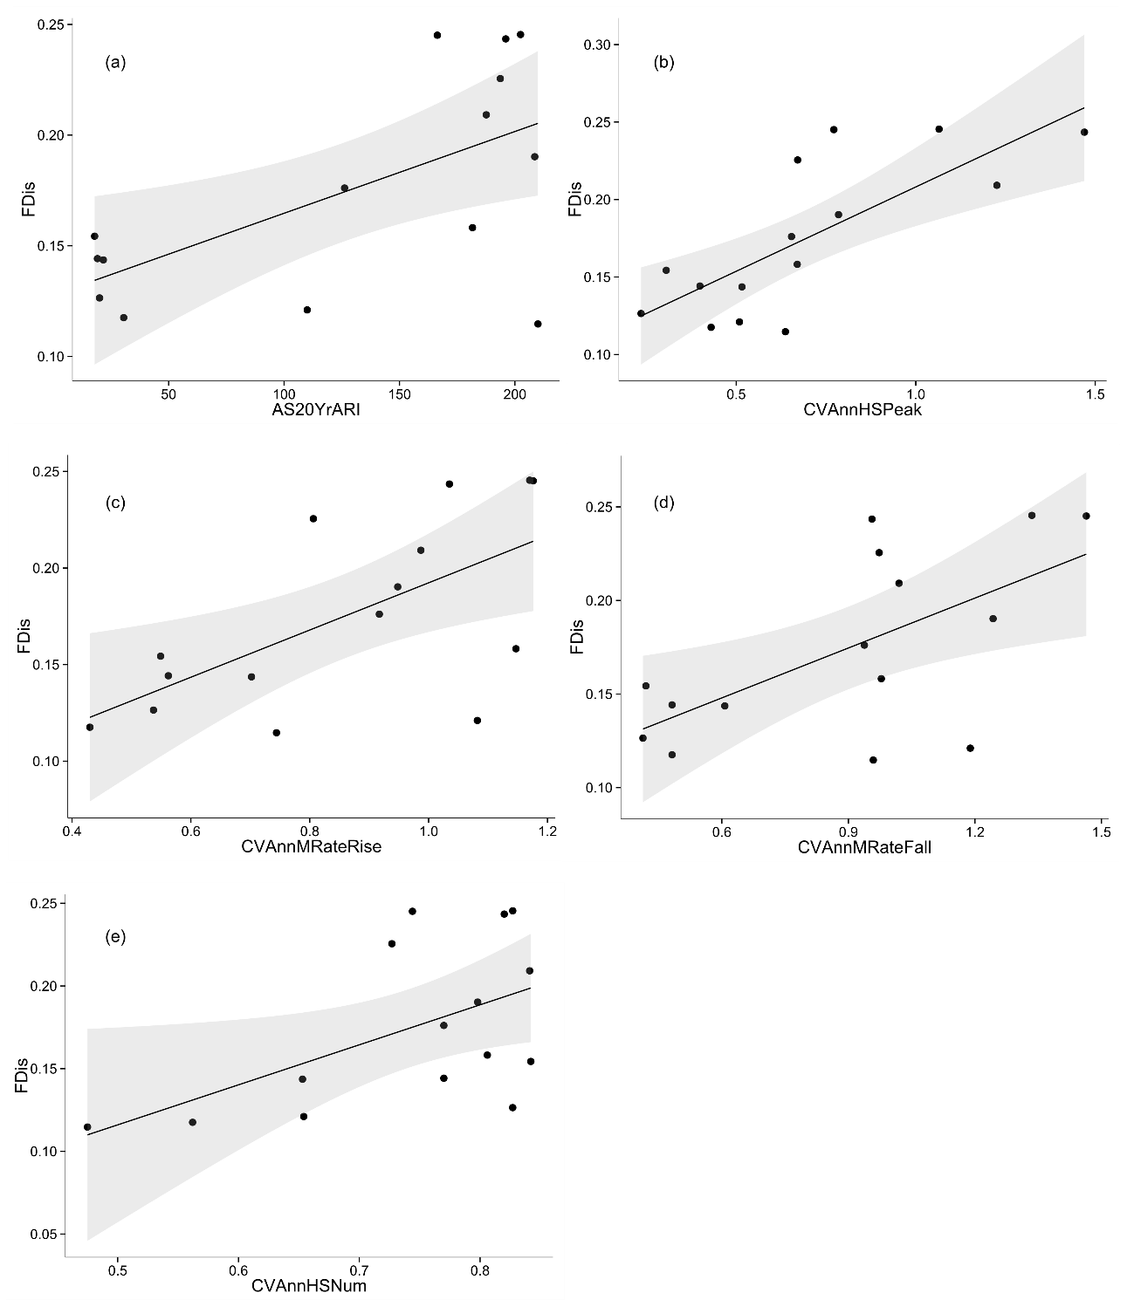

Figure 1. Relationships between FDis and hydrological metrics describing a) magnitude of the 20 year average return interval flood (AS20YrARI), b) interannual variability in high flow magnitude (CVAnnHSPeak), c) interannual variability in flood rise rate (CVAnnMRateRise), d) interannual variability in flood fall rate (CVAnnMRateFall), e) interannual variability in high flow frequency. Fitted lines depict ordinary least squares regression models. All models are linear fits. Shaded areas depict the smoothed 95% confidence interval around the regression model. All relationships shown are significant.

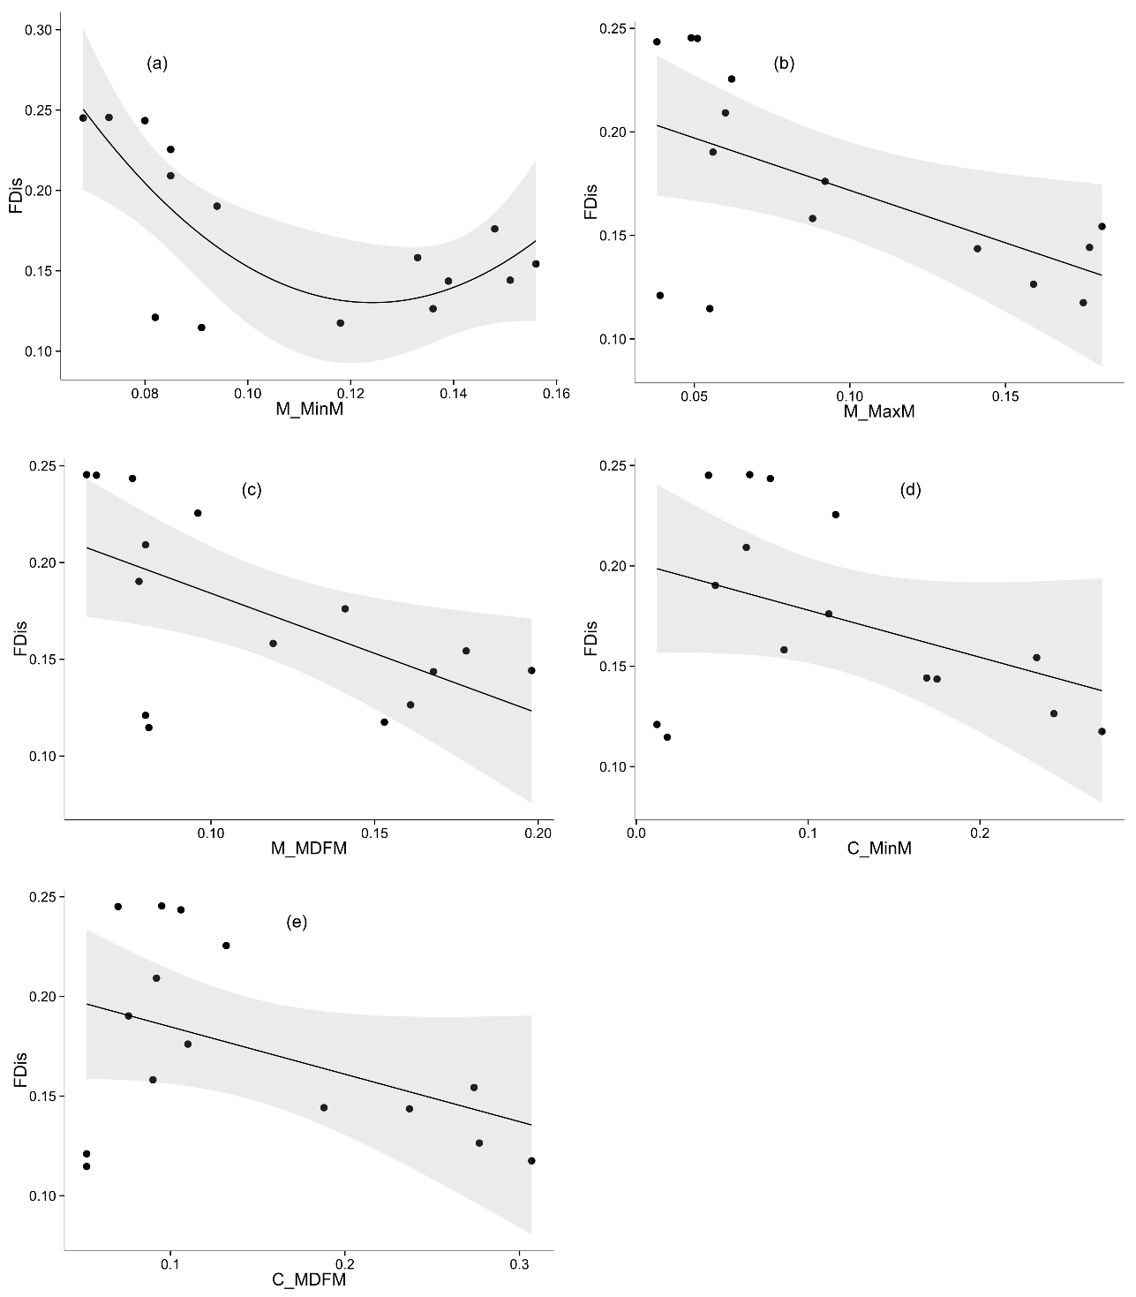

Figure 2. Relationships between FDis and hydrological metrics describing a) contingency of monthly minimum daily flow (M_MinM), b) contingency of monthly maximum daily flow (M_MaxM), c) contingency of monthly mean daily flow (M_MDFM), d) constancy of monthly minimum daily flow (C_MinM), e) constancy of monthly mean daily flow (C_MDFM). Fitted lines depict ordinary least squares regression models. a. is a quadratic fit, b. – e. are linear fits. Shaded areas depict the smoothed 95% confidence interval around the regression model. a. – c. depict significant relationships, d. and e. depict non-significant relationships (note the strong influence over the regression fit of the two points at the lower bound of FDis).

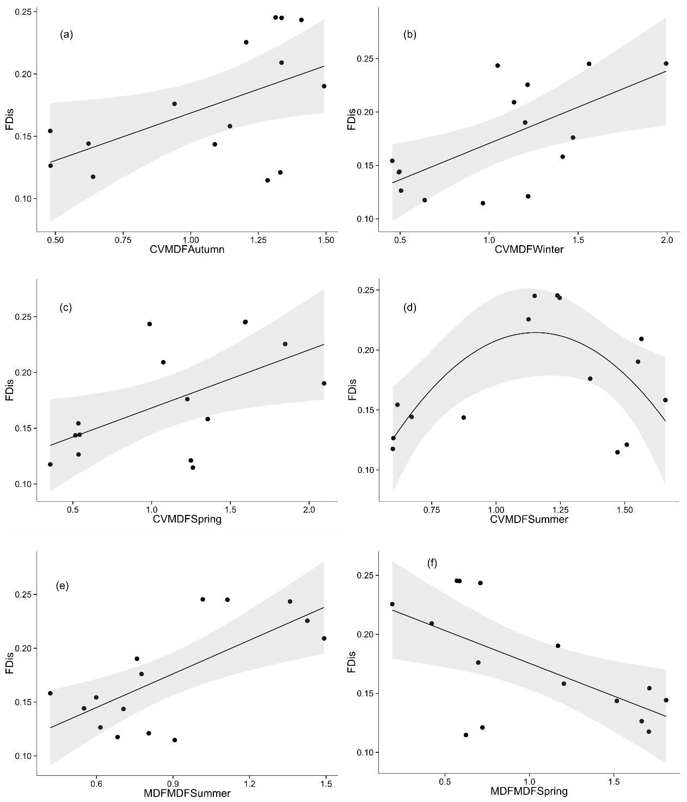

Figure 3. Relationships between FDis and hydrological metrics describing a) variability in autumn mean daily flow, b) variability in winter mean daily flow, c) variability in spring mean daily flow, d) variability in summer mean daily flow, e) mean daily flow in summer, f) mean daily flow in spring. Fitted lines depict ordinary least squares regression models. All models are linear fits except d. which is a quadratic fit. Shaded areas depict the smoothed 95% confidence interval around the regression model. All relationships shown are significant.